**Interpreting Linear Regression:**

Finding the best-fit linear line and the ideal intercept and coefficient values such that the error is minimized is the major goal of a linear regression model. Error is the discrepancy between actual and predicted values, and the objective is to minimize this.

**Example:**

Imagine that a bunch of computer enthusiasts founded a company called TechEx Inc. Since 2018, TechEx has been flourishing. On the other hand, I had planned to invest in that business, and I'm wondering if I should put my money into TechEx over the course of the coming year or not.

Let's say you acquire a few shares since you don't want to risk a lot of money. You start by researching TechEx's stock values since 2018.

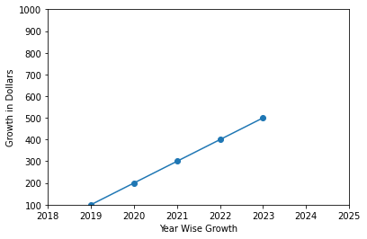

The following graphic clearly shows that TechEx is expanding at an incredible rate, as seen by the fact that their stock price has increased from $100 to $500 in just a few short years. You want to invest in TechEx in 2023 because you want your money to expand along with the business.

You just extrapolated your mental model to forecast the value of Y for a value of X that is not even known to you. Because you were unable to pinpoint the exact stock price in 2023, the mental calculation you made is inaccurate in any case. You simply anticipate that it will cost more than $500.

Here's where regression comes into play. Finding the line that best matches the data points on the plot is the goal of regression, which allows us to determine where the stock price is likely to be in 2023.

**References:**

Python for Data Analysis: O'Reilly 2nd edition, Data Wrangling with Pandas, NumPy, and IPython, Wes McKinney

<https://towardsdatascience.com/linear-regression-model-899558ba0fc>

<https://medium.datadriveninvestor.com/math-behind-data-science-vol-3-8f1b414c2cb7>